Joel Edwards
Course: Java Programming 1
Homework 6
April 13, 2011

Source:

CalculatorGUI.java:
import java.awt.Button;
import java.awt.Label;
import java.awt.TextField;

public class CalculatorGUI
extends Applet
{
public static final long serialVersionUID = 1L;

protected TextField fieldA = new TextField(20);
protected TextField fieldB = new TextField(20);

protected Label resultLabel = new Label("0. ");

protected Button addButton = new Button("+");
protected Button subButton = new Button("-");
protected Button mulButton = new Button("X");
protected Button divButton = new Button("/");

protected CalculatorLogic logic = new CalculatorLogic(fieldA, fieldB, resultLabel);

public void init() {
// Add widgets to Applet
add(fieldA);
add(fieldB);
add(resultLabel);
add(addButton);
add(subButton);
add(mulButton);
add(divButton);

// Attached ActionListeners to our buttons
addButton.addActionListener(logic);
subButton.addActionListener(logic);
mulButton.addActionListener(logic);
divButton.addActionListener(logic);
}
}
CalculatorLogic.java:
import java.awt.Label;
import java.awt.event.ActionEvent;
import java.awt.event.ActionListener;
import java.awt.TextComponent;

public class CalculatorLogic
implements ActionListener
{
private TextComponent inputA = null;
private TextComponent inputB = null;
private Label output = null;

public CalculatorLogic(TextComponent inputA, TextComponent inputB, Label output) {
this.inputA = inputA;
this.inputB = inputB;
this.output = output;
}

public void actionPerformed(ActionEvent evt) {
double valueA = 0.0;
double valueB = 0.0;
try {
valueA = Double.parseDouble(inputA.getText());
valueB = Double.parseDouble(inputB.getText());
Button source = (Button)evt.getSource();
String op = source.getLabel();
if ("+".compareTo(op) == 0) {
output.setText("" + (valueA + valueB));
} else if ("-".compareTo(op) == 0) {
output.setText("" + (valueA - valueB));
} else if ("X".compareTo(op) == 0) {
output.setText("" + (valueA * valueB));
} else if ("/".compareTo(op) == 0) {
if (valueB == 0.0) {
output.setText("Divide by zero!");
} else {
output.setText("" + (valueA / valueB));
}
} else {
output.setText("Unsupported Operation!");
}
} catch (NumberFormatException e) {
output.setText("Invalid Input!");
}
}
}

Calculator.html:
<html>
<head>
<title>A Simple Calculator</title>
<meta http-equiv="pragma" content="no-cache" />
</head>
<body>
<applet code="CalculatorGUI.class" width="200" height="200">
</applet>
</body>
</html>

Test Output:
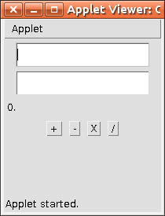
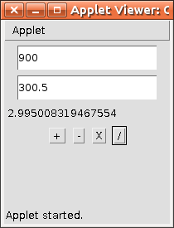

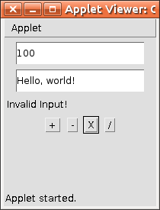
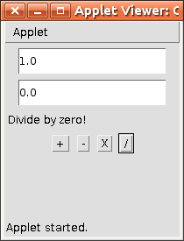

Webpage:
http://scaglietti.dyndns.org/Calculator/

